Paxton Play Area Consultation

Scottish Borders Council has been allocated funding to improve the play area/recreation facilities at Paxton Play Park. The facilities are programmed to be updated in 2024/25. We are now holding a public consultation to seek the views of the community as to what play equipment/recreational equipment they would like to see installed in this area.

About you – The person completing this form is a;
Child/young person (please advise of your age below)
Adult (on behalf of a child/children in the following age/age range)
Age  (Please tick) | 0-2 | 3-5 | 6-10 | 11- 13 | 13+

Do you live in Paxton? | Yes | No
Do you currently use this recreational facility/ play area? | Yes | No

Would you rather that the funding was used;
- For play equipment only
- For play equipment and additional/alternative recreational equipment

If it were possible to add alternative recreational equipment, what would you like to see included in this area?

If improvements, additions were made, would this encourage you use the area more? | Yes | No

What would be your top 10 priorities (in order) for new play area equipment? Please rank 1-10 (1 highest, 10 lowest)
Large Multi-Play Unit  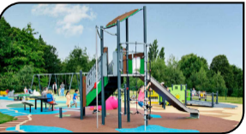 |  | Agility trail  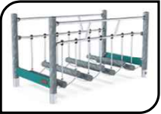
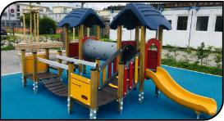  Small multi play unit |  | Roundabout  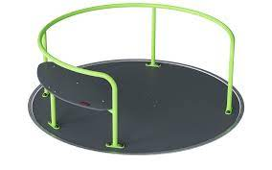
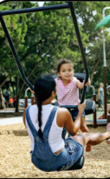  Swings  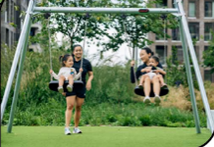 |  | Sensory equipment  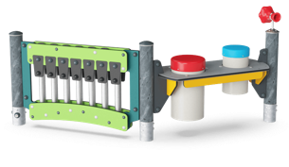
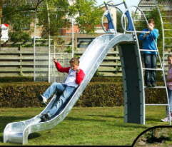  Slides |  | 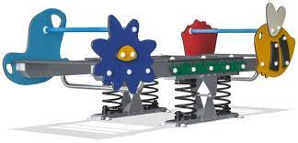  See-saw  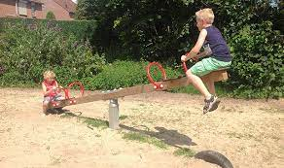
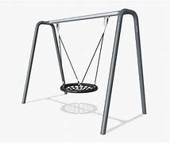  Basket Swing |  | 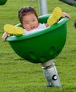  Spinners  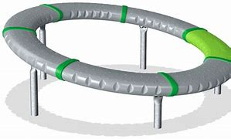
Panel boards  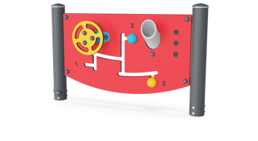 |  | Springers  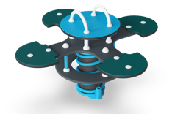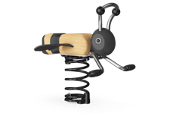
Other – please comment

Please feedback any other thoughts or comments on the play area / recreation facilities here;

